Prekindergarten Expansion Grant
Notice of Funding Availability (NOFA) FY 2021

Please return completed application to MSDE by Friday, May 1, 2020
No later than 4:00 p.m. to the address below:

Maryland State Department of Education
Division of Early Childhood
Attn: Nykia Washington
200 West Baltimore Street, 6th Floor
Baltimore, MD 21201
*Grant awards are dependent on funding availability *To request accessible documents, please contact Nykia Washington Nykia.Washington@maryland.gov
Proposal Description:
Type of Application: Prekindergarten Expansion Grant

Name of Grant Program: Prekindergarten Expansion Grant

Authorization: House Bill 1415 (2018), Chapter 316 - “Education Commission on Innovation and Excellence in Education”

Dissemination: Tuesday, March 17, 2020
Deadline: Friday, May 1, 2020 No later than 4:00 p.m.

Submission: Submission must be an original plus one (1) paper copy bound by paperclip.
Purpose:
Expand access to public prekindergarten for three-year-olds and four-year-olds with priority given to (a) students from families with household incomes up to 300 percent of Federal Poverty Guidelines (FPG) and (b) students with special education needs, regardless of income.
Grant Eligibility:
Applicants eligible to receive the grant must be local public school systems (LSS) or qualified vendors (as defined in COMAR 13A.06.02)

Preference will be given to programs published at Level 5 in Maryland EXCELS or published at Level 4 with a plan in place to publish at Level 5 within one year.

Other applicants may be considered as noted: community-based providers must be published at Maryland EXCELS Level 3 with a plan approved by MSDE to achieve Level 5 within five years. LSS must be published at Level 4 with a plan approved by MSDE to achieve Level 5 within five years.

Special Considerations:
For LSS applicants, local general education and special education leadership are strongly encouraged to collaborate on the development of the grant proposal.

- Combining multiple funding streams offers increased opportunities for the inclusion of children with Extended Individualized Family Service Plans (IFSPs) or Individualized Education Programs (IEPs) for whom a regular early childhood program with typically developing peers has been determined by the child’s IFSP/IEP team to be the appropriate natural and least restrictive environment (LRE). The participation of children served through an Extended IFSP or an IEP in public prekindergarten programs provides access to the general early childhood education curriculum and instructional program, further supporting a narrowing of the school readiness performance gap with typically developing peers. Fully inclusive options have been shown to work for children across disability groups and levels of severity (children with developmental delays, mild to severe; children with ASD; children with multiple disabilities; children with significant social and emotional needs; children with hearing impairment; children with limited mobility).

Required Grant Components:
- A description and documentation to show how the applicant will meet the Definition of a High Quality Prekindergarten Program as defined in Appendix A.
- Documentation of how families meet the income eligibility criteria according to the Federal Poverty Guidelines (FPG) must be collected and maintained on-site.
- Description of the program’s family engagement strategies in accordance with the Maryland Early Childhood Family Engagement Framework.
(earlychildhood.marylandpublicschools.org/system/files/filedepot/4/md_fam_engage.pdf)The virtual Family Engagement Toolkit can be found here:
https://marylandfamiliesengage.org/family-engagement-toolkit/goals/.
- Verification of published MD EXCELS Level with a plan in place to achieve Level 5 by the identified deadline.
- Description of professional development activities for pre-k instructional staff.
- List of partners and specific roles as they relate to the grant.
- Upon receipt of grant award, all sub-grantees must have a completed and signed Memorandum of Understanding (MOU) between the local school system (LSS) and community-based public PreK or early care and education providers in the school catchment area*. MOUs must be submitted to program monitor by Monday, November 2, 2020. See Appendix B for sample MOU and Appendix C for a list of local school system Early Learning Supervisors. The MOU must demonstrate a commitment to ongoing collaboration in the following areas (at minimum):
  - Services for children with disabilities,
  - Services for three- or four-year-olds who are English learners to align with LSS policies,
  - Coordination of prekindergarten enrollment,
  - Professional development opportunities, and
  - Transition planning.
- Community-based programs: a license check will be performed prior to the final awarding of the grant to ensure a valid license is held and there are no major health and safety violations.
- Final awarding of the grant will be determined by the applicant meeting all grant requirements.
- All grant requirements must be met prior to the start of the school year, including the certified teacher requirement to avoid a disruption in grant funds.
- Invoices will not be paid unless grant requirements have been met
Submission Requirements:
- Signed Cover Sheet
- Project Summary
- Classroom Staffing Pattern
- Project Management, Key Personnel
- Collaborating Partners
- Quality Benchmarks and Programmatic Plan
- Evaluation & Monitoring
- Participation in Maryland EXCELS (certificate indicating published level)
- Signed MSDE Budget Forms
- Signed Assurances Page
- Implementation Plan
- All supporting documentation
Proposal Review:
The review of proposals will be a two-part process.
- Written applications will be pre-screened for submission requirements and inclusion of all required sections. Applications not meeting the prescreen requirements will not be read.
- Final approval of awards will be determined by the Division of Early Childhood

Award:
Initial notification of grant approval will be sent by May 29th. Processing of the official Notice of Grant Awards (NOGA) will begin on July 1st; this process can take 6-8 weeks. Once the official NOGA is received, an invoice template will be sent for billing. Once an invoice has been approved by MSDE, payment can be expected within 15 business days. For budget planning purposes, please note that funds may not be available until September 15th.

Community-based programs, meeting all grant requirements, will be eligible to receive a 15% advance upon request; however the advance may be received no later than September 15th. Community-based programs requesting an advance must complete Appendix D (Request for Payment Advance) and submit it with the application. Advance requests received after the application has been submitted will not be considered.

*A program may not invoice for the grant until all grant requirements are met, including the certified teacher requirement.
Length of Grant:
July 1, 2020– June 30, 2021

Period of Operation:
August 2020- June 2021 (School Year 2020-2021)

Grant Process Timeline:
Date | Activity
Tuesday, March 17, 2020 | Application disseminated
Tuesday, March 24, 2020 | Technical Assistance Webinar  12:30 pm and 6:00 pm
Friday, May 1, 2020 | Application due to MSDE
April – May, 2020 | Applications reviewed
Friday, May 29, 2020 | Initial notification of grant approval/Notice to proceed
Friday, June 5, 2020 | Last day to submit revised budget narrative and C-125 or the State may rescind the grant
Wednesday, July 1, 2020 | Notice of Grant Award (NOGA) system opens.  *Processing of NOGAs will begin; this process can take 6-8 weeks for processing.
Monday, August 31, 2020 | NOGA issued and Advance Request submitted for processing by August 31st (please allow up to two weeks to receive payment)
Tuesday, September 15, 2020 | Anticipated date for grantee to receive advance

Funding Per Prekindergarten Student: $10,000 (full-day new slot) and $5,000 to improve an existing slot to meet the Definition of High Quality Prekindergarten (See Appendix A)

Definitions:
Full-day, New Slot:
LSS’s – full-day slots for children between 186% and 300% of the Federal Poverty Guidelines (FPG). See Appendix I - FY2020 Federal Poverty Guidelines Chart

Community-based programs – full-day slots for all children up to 300% of the FPG
Improved Slots: slots improved to meet the Definition of High Quality Prekindergarten (See Appendix A)

Head Start and LSS’s only
LSS’s – increase half-day slots to full-day slots for children below 186% of the FPG
Head Start programs - improve slots to meet the definition of high quality prekindergarten by doing any of the following:

- Extending programs from half-day to full-day.
- Employing and compensating a teacher with a Maryland P-3 teacher certification

NOTE - *ALL PREKINDERGARTEN EXPANSION SLOTS MUST BE FULL-DAY

Coordination with Supplemental Prekindergarten Grants to Local School Systems (LSS):
Local School Systems that receive Supplemental Prekindergarten Grants and Prekindergarten Expansion Grants in FY21 will be expected to increase the number of four-year-old children served in full-day prekindergarten as reported by the official September 30th enrollment count. For example, if the LSS receives Supplemental Prekindergarten Grant funds in FY21 for serving 100 four-year-old children in full-day prekindergarten the prior year (2019-2020 school year) and is also awarded the Prekindergarten Expansion Grant to serve 40 four-year-olds, the LSS must serve a minimum of 140 four-year-olds in full-day prekindergarten in FY21. The September 30, 2020 enrollment data submitted to MSDE must reflect this increase. (Please see Appendix E – FY19/September 30, 2019 Enrollment Count).

LSS will be required to sign an Assurance Form and submit with the application (Please see Appendix F – Pre-K Expansion Assurance Form)

Fund Use:
- Salaries, wages, and fringe benefits for teaching staff. (Note: State certified teachers must be compensated commensurate with the entry salaries of the LSS in which the program is located. See Appendix G – Teacher Salary Schedule.).
- Equipment, materials and supplies (e.g., classroom furniture, instructional materials including MSDE approved curriculum resources to support the Maryland Early Learning Standards, book supplies for family literacy or math or math activities.).
- Reasonable rental costs are allowable and should be reviewed periodically. Contact the fiscal grant manager for specific conditions and requirements if property rental costs are included in the budget narrative.
- Technology costs may not exceed 10% of the total fund request.
- Costs associated with maintaining MSDE or national accreditation status.
- Costs for contracts to administer the screening and intervention services for prekindergarten students.
- Costs associated with the provision of staff and professional development activities to support recertification of qualified teaching staff.
- Costs associated with evaluation and monitoring of the project (may not exceed 5% of the total fund request).
- Indirect costs (may not exceed 10% of the total fund request).
- Costs for one meal per day for students.
- Costs for academic field trips.

Funds may not be used for:
- Supplanting existing services, or
- Capital Improvements.

The General Education Provisions Act (GEPA), Section 427:
Each application must develop and describe the steps the applicant will take to ensure equitable access to, and equitable participation in, the project or activity to be conducted with such assistance, by addressing the special needs of participants, and other program beneficiaries in order to overcome barriers to equitable participation.

Requirements:
Grantees must submit:
- Quarterly Progress Reports using MSDE supplied forms;
- Annual financial report at the end of the grant period;
- Quarterly Enrollment and Attendance Reports using MSDE supplied forms;
- MOU and Collaboration Check-in Form; and
- Monitoring Tool (spring).

The original proposal and one copy bound by paper or binder clip should be submitted to:
Maryland State Department of Education
Division of Early Childhood
200 W. Baltimore Street – 6th Floor
Baltimore, MD 21201
Attention: Nykia Washington

Program Contact:
Nykia Washington 410-767-0088 (telephone) 410-333-6226 (fax)
Nykia.washington@maryland.gov

**If accessible forms are needed, please inform the Program Contact listed above.
Non-Discrimination Statement:
The Maryland State Department of Education does not discriminate on the basis of age, ancestry/national origin, color, disability, gender identity/expression, marital status, race, religion, sex, or sexual orientation in matters affecting employment or in providing access to programs and activities and provides equal access to the Boy Scouts and other designated youth groups. For inquiries related to Department policy, please contact:

Equity Assurance and Compliance Office
Office of the Deputy State Superintendent for Finance and Administration Maryland State
- Department of Education
- 200 W. Baltimore Street - 6th Floor
- Baltimore, Maryland 21201-2595
- 410-767-0426 - voice
- 410-767-0431 - fax
- 410-333-6442 - TTY/TDD
The application begins on the following page

COVER SHEET
FY 2021
Prekindergarten Expansion Grant Application
Name of Applicant: Fed ID No: ___________________________

Qualified vendors only: DUNS No:
To register the DUNS Number visit the website below. This is required to receive funding.
https://www.sam.gov/portal/SAM/##11

Address:

City: |  |  |  |  |  | ZIP:
Telephone: |  |  | FAX: |  |  | e-mail:
Contact Person:
Address of contact person (if it is different from the address above):

City: |  |  |  |  |  | ZIP:
Telephone: |  |  | FAX: |  |  | e-mail:
Please check one:
▪ Public School
▪ Public Charter School
▪ Community-based Provider
▪ Head Start Program
▪ College, University or Vocational/Technical School
Prekindergarten Site Selection
*Please list all schools/sites

 | Name of  Program/School | School ID  Number or Child Care License Number |  | Street Address |  |  | City | Zip Code

*Add rows as necessary

Number and Type of Slots Requested

School/Program | Slots  School Year 2019-2020  (current grantees only) |  | Slots Requested  School Year  2020-2021  (by type) |  | Total Requested for School Year  2020-2021
 | Actual # of new slots filled | Actual # of improved  slots filled | #  Full-day New | #  Improved |  | How Will  Slots be  Improved?*  (See Codes  Below) Select all that apply
*Add rows as necessary

The program/school must request at least 5 slots in order to receive grant funds
The last column refers only to the number of improved slots for the 2020-2021 school year

Improved Slot Codes:

- – Half-day to Full-day
- - Employing and compensating a teacher with a Maryland P-3 teacher certification

Note: All Prekindergarten slots must be full-day

Of the total number of slots requested for the 2020 - 2021 school year please identify:

_______ 3-year old slots

_______ 4-year-old slots
Local School Systems (only)

Local School Systems that receive Supplemental Prekindergarten Grants and Prekindergarten Expansion Grants in FY21 will be expected to increase the number of four-year-old children served in full-day prekindergarten as reported by the official September 30, 2020 enrollment count.

 | A | B | C
 | Number of four-year-olds served in full-day prekindergarten on the September 30, 2019 Enrollment Count (See Appendix E) | Number of four-year-olds requested for funding in the FY21 Prekindergarten Expansion Grant Program | A plus B = the minimum number of four-year-olds to be served in FY21 (as will be reported in the September 30, 2020 Enrollment Count).
EXAMPLE | 100 | 40 | 140
LSS Applicant (total for all programs)

Classroom Staffing Pattern

This document can be updated upon final awarding of the grant. If a lead teacher has not yet been hired, please indicate TBD. Note: A copy of the teacher certification for all teachers in TDB category will be required prior to the first day of school to avoid a disruption in grant funds. Invoices will not be processed if this requirement is not met.

School/Program/  Classroom | Age of children:  3, 4, or mixed-age | Teacher | MD State Teacher Certification  Y or N | Work Hours | Para Educator Assistant Teacher | Work Hours

*Add rows as necessary

Notes:
- The teacher must be employed full-time (assigned to the grant classroom for the 6.5 hour instructional day).

- A Director cannot be regarded as the teacher unless he or she is working in the classroom full-time for the 6.5 hour instructional day.

- There must be a Maryland State certified teacher in each classroom.

Application Signature:

_______________________________ _________________
Head of Organization Date

Project Update - Fiscal 2021 (500 words or less) *For Returning Grantees Only
Based on last year’s comprehensive program evaluation for continuous improvement, please respond to the following questions (in summary format: what did you learn from the process? What data and tools were used to support this process? Based on what you learned, what changes will you make and how will you continue to improve for next year?

Project Summary - Fiscal 2021 (500 words or less)
Describe in a summary format the following: Specific goals and objectives of the Prekindergarten Expansion Grant; recruiting eligible students; maintaining enrollment of eligible students; hiring a certified teacher and paying that teacher a salary commensurate to the LSS; meeting school readiness goals; establishing an MOU with the school system to support children with special needs and English learners and for professional development; continuous quality improvement; meeting and maintaining level 5 in Maryland EXCELS; plan for family engagement and comprehensive services.

Priority Points
Please check the box(es) below if you are claiming priority points (extra points) for any of the priority areas listed below and provide a description:
Local School Systems (LSS) ONLY

Check Here
- LSS will partner with community-based early childhood programs to establish Pre-K slots
Please describe how you will approach this partnership as well as how it will be implemented:

All Programs

- The program will enroll English Learners (EL)
Please describe how you will ensure that English Learners are provided access to the program, what criteria will you use to determine if a child is an EL, how eligible families will be recruited, and how you will support these children in full, meaningful participation throughout the program:

- The program will enroll children with disabilities, regardless of income
Please describe how you will ensure that children with developmental delays/disabilities are provided access to the program, how eligible families will be recruited, and how you will support these children in full, meaningful participation throughout the program, to include collaborating with early intervention or preschool special education providers as appropriate:

Quality Benchmarks and Programmatic Plan

- Describe how you will ensure that children from economically disadvantaged backgrounds are provided access to the program, how eligible families will be recruited for the program, and how will the recruitment efforts be coordinated between local school systems and qualified vendors?

- Lead teachers in both public and private settings must have specialized training in early childhood education and have State certification in early childhood education. Please indicate the qualifications of the lead classroom teacher(s) and commensurate pay rate to the local school system. (Attach State Teacher Certification). If teacher is not yet hired, please attach the job description/announcement showing the requirements for a state certified teacher. Note: All classrooms must have a certified teacher by the first day of school to avoid a disruption in funding. Invoices will not be paid until this requirement is met.

**There must be a certified teacher in each classroom

Salary must be commensurate to minimum salaries of local PreK-12 instructional staff in your jurisdiction (See Appendix G). List Teacher Salary $____________________

- Assistant teachers must hold a minimum of a high school diploma, but preferably an AA, CDA or equivalent training (i.e. Level 4 in MSDE Credentialing Program), or enrolled in a program to obtain these credentials. Please indicate the qualifications of the classroom assistant teacher (Attach a copy of degree, diploma, credential, or CDA).
- Indicate how the prekindergarten instructional staff will participate in yearly professional development activities.
- Describe how the program will provide a full-day (6.5 hour) session/180 days per school year?
Please note: Tuition may not be charged for the 6.5 hour day; tuition may be charged only for additional wrap around services when applicable.
- Indicate which of the following prekindergarten curriculum options is utilized in the prekindergarten program (See Appendix H for the list of MSDE recommended curricula):
State approved comprehensive curriculum
Name _____________________________________
LSS - Local school system curriculum that aligns with the Maryland College and Career-Ready Standards is accepted.
- Describe how both screening and referral services covering at least vision, hearing, speech and language, health, and physical development will be provided. Programs must offer, either directly or through coordination with local school systems or local departments of health and social services, additional support services for participants. (These services may include parenting support or training including those with languages other than English, physical and mental health and wellness services (e.g., SEFEL), and early intervention for children with disabilities and/or special health care needs). Please indicate the how these services will be provided specifically (e.g. provide the name of the individuals, organizations, and community partners providing these services).

Project Management/Key Personnel:
List all administrative key personnel responsible for the successful implementation and monitoring of the grant requirements and provide resume(s).
*Note: Resumes apply to key administrative personnel only. Teaching Certifications must be submitted for all lead teachers funded by the grant.

Collaborating Partners:
Describe the nature of collaboration between the local school system and community based Public PreK or early care and education providers in the school catchment area (e.g. Access to professional development, coaching/mentoring, ELL/ESOL services, special education services, transitions, etc.)
List additional collaborating partners and describe their respective roles in the successful outcome of this project.

Evaluation and Monitoring of Learning:

Describe how the progress of all prekindergarten students will be monitored throughout the year and how it supports school readiness? How are parents informed about student progress and/or areas of concern?

What type of data and instruments will be used to monitor the quality of the prekindergarten program? (e.g., CLASS and/or use of other quality indicators or rating systems)?

Maryland EXCELS Participation and Publishing:

Current Level _____________

Date published ____________

** Attach copy of certificate(s)

What tools and strategies have been put in place to maintain the quality standards for your current level in Maryland EXCELS or to publish at Level 5 by the identified deadline?

Accreditation:
Accrediting Agency _________________________________________________

Expiration Date _____________________

**Attach copy of certificate(s)

Budget Narrative (FY21) Complete for July 1, 2020 – June 30, 2021
Directions: Please provide a detailed description of the requested funds that will be spent by using the categories listed below. For
Community Based Programs, Transfer the subtotals of these categories onto line 214 (Community Services) of the enclosed MSDE Budget Form. Then list the total requested budget amount on the line TOTAL EXPENDITURES BY OBJECT. Sign and date the MSDE C-125 Budget Form.
Line Item | Requested Amount | In-Kind Contribution | Total
1. - Salaries and Wages (List separately for each position.
Teacher salary must be commensurate to local school system).
Subtotal
2. Contracted Services
Subtotal
3. Supplies and Materials (including classroom furniture)
Subtotal
4. Other Charges (e.g., fringe costs, field trips, subscriptions, travel)
Subtotal
5. Equipment (e.g. Technology)
*Technology must be no more than 10% of budget with MSDE Approval. **Items less than $5,000 per unit should be listed in Supplies and Materials.
8. Transfers (indirect costs)
Subtotal
Grand Total

GRANT
Prekindergarten Expansion Grant | GRANT RECIPIENT NAME
NAME

RECIPIENT
GRANT #
MSDE
GRANT#

SCHOOL / CENTER NAME
FUND SOURCE
 | GRANT PERIOD | July 1, 2020 – June 30, 2021

REVENUE
SOURCE CODE
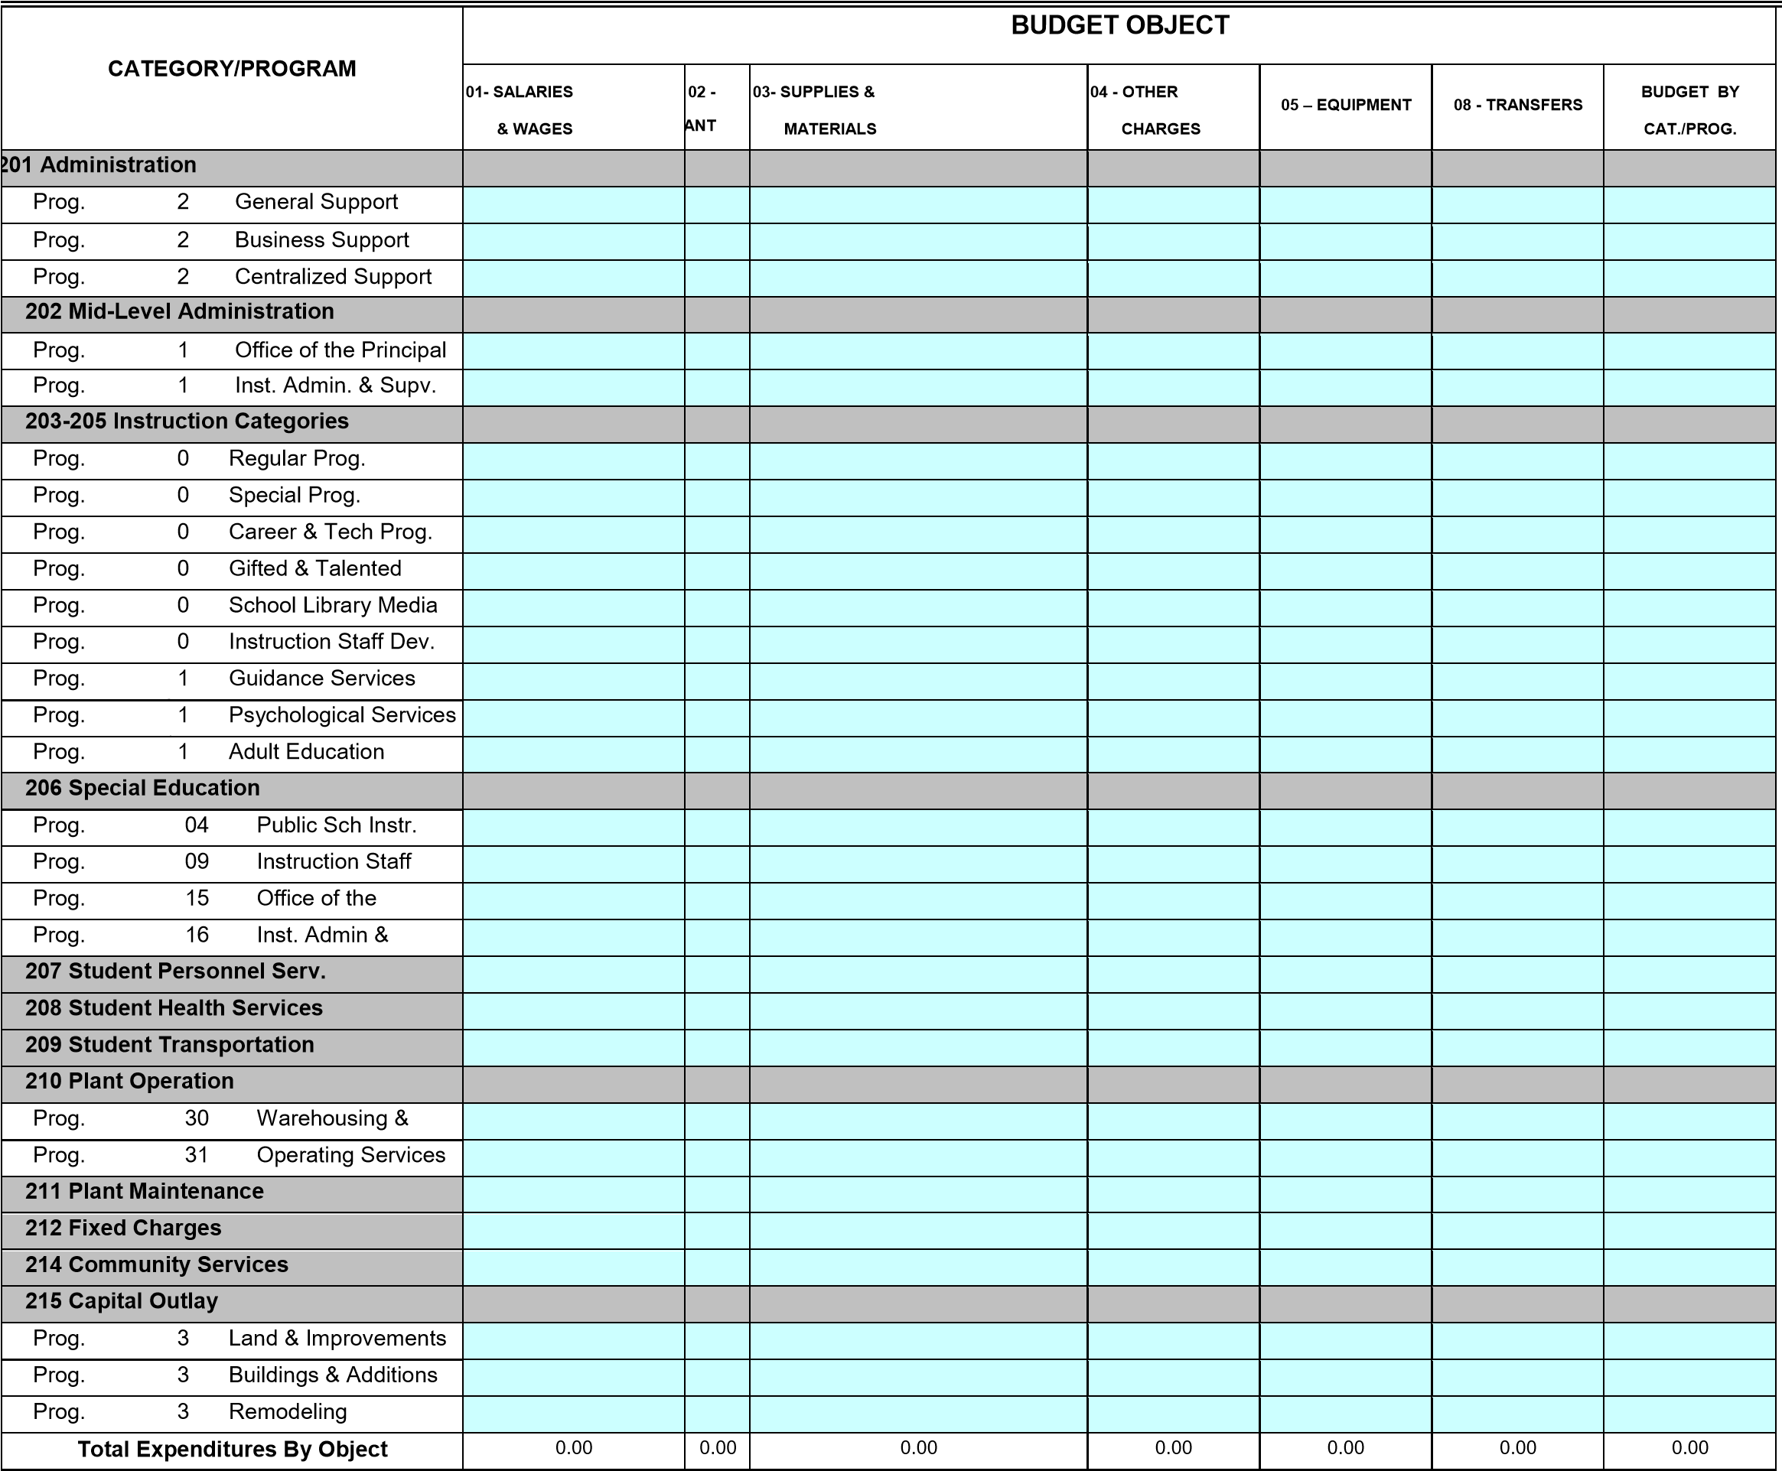

Finance Office Approval
Supt/Agency Head Approval
MSDE Grant Manager Approval
Name Signature Date Telephone #

This page is intentionally left blank

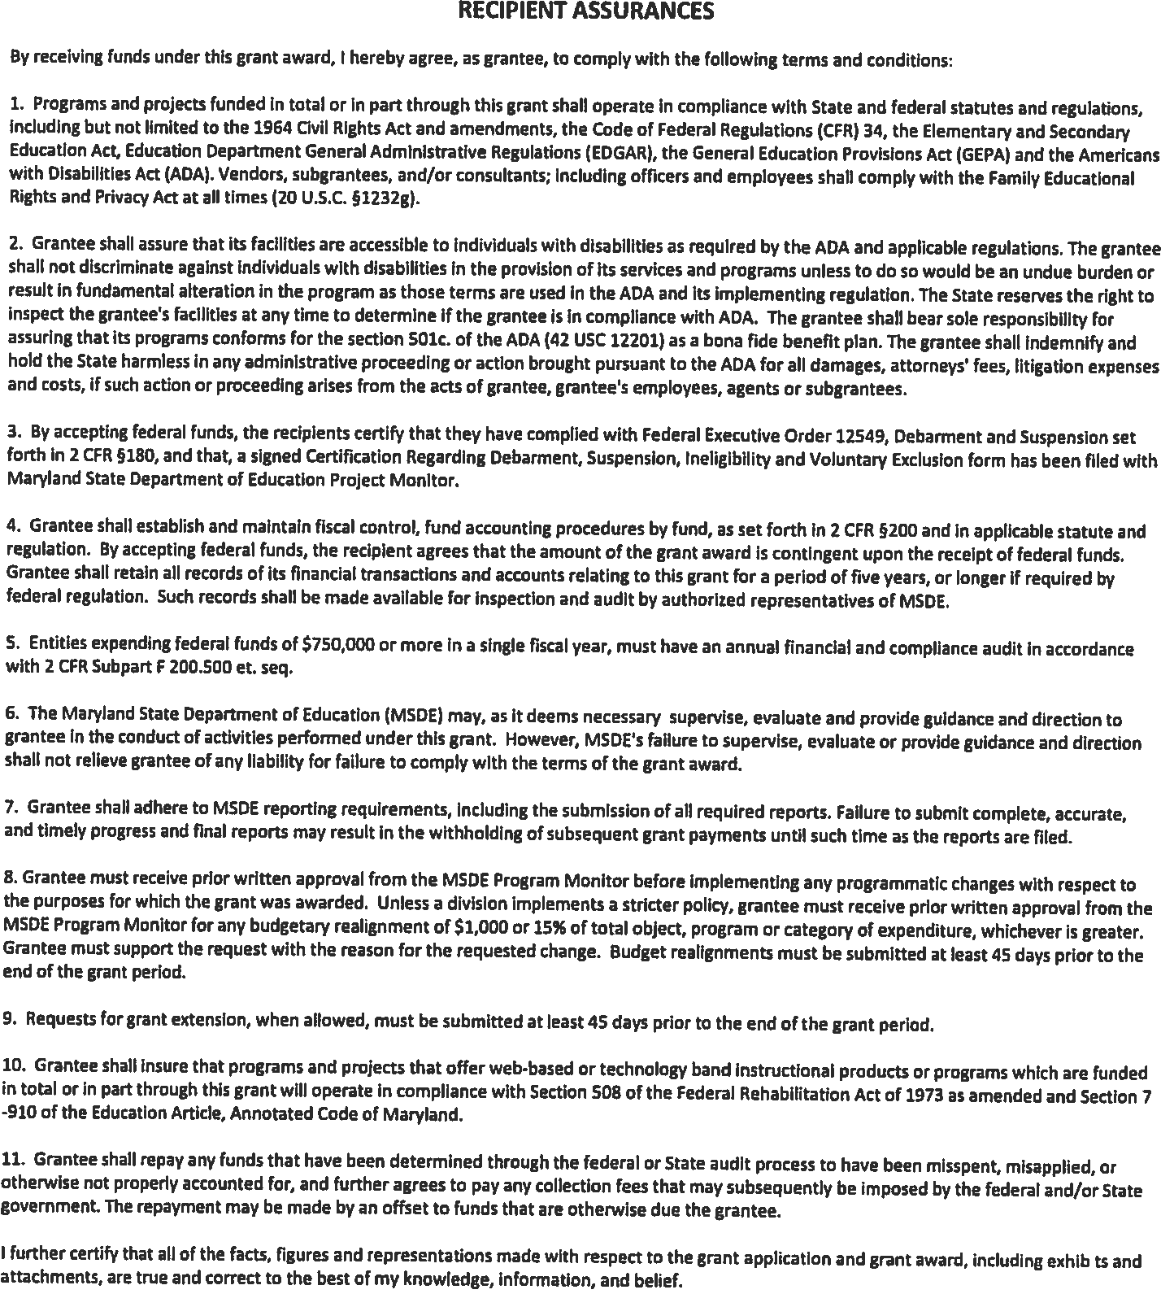
Prekindergarten Expansion Grant

Application
FY 2019

IMPLEMENTATION PLAN
Instructions: Please complete the implementation plan (the implementation plan should be aligned to the budget narrative)

*See next page for information on Goals, Strategies, and Activities and SAMPLE
IMPLEMENTATION PLAN on p.26

(Reproduce this form as needed)

GOAL(s):
STRATEGIES:
Activities | Dates |  | Responsibility | Funding |  | Date Achieved  TO BE FILLED OUT  DURING MONITOING
 | Date  Initiated | Expected  Completion Date | Person Responsible for Outcome | Funding Required | In-  Kind

Goals, Strategies, and Activities

Goals
State the overall goal of your project at the top of the Implementation Plan. The goal should address the main problem (e.g., to increase the number of children being ready for school). While you must have at least one goal, it is possible to have multiple goals; however, the more goals you establish the more complex your project becomes. Goals must have deadlines of one year.

Strategies
Strategies are broad approaches (methods, procedures, techniques) employed to accomplish your outcomes. When determining your strategies, you should consider the clients you are targeting and how will they use or be affected by the services you provide. Programs must also include strategies about family engagement, partnerships with local school systems, and support services such as screening and referral of students with special needs.

Activities
Activities are the specific steps you will take to accomplish the project goal, and involve direct service to clients (children, parents, and teachers). Examples include specific teacher professional development activities, family nights, and coaching/mentoring sessions. They may take place on a single date (e.g., 1-day training session) or over a period of time (e.g., ongoing technical assistance) List the activities that your project will implement. Then relate each activity to a strategy.

SAMPLE IMPLEMENTATION PLAN

GOAL(s): To provide a high quality Pre-Kindergarten experience that prepares children for school success in kindergarten and beyond.
STRATEGIES: Professional development and coaching for teachers , a focus on family engagement and collaboration with outside agencies /school systems, implementation of a play based, developmentally appropriate curriculum
Activities | Dates |  | Responsibility | Funding
 | Date  Initiated | Expected  Completion Date | Person Responsible for Outcome | Funding Required | In-Kind
Teachers will undergo training in the use of the  InvestiGator Club curriculum. | June 2016 | June 2016 | Director | $24,000.00
Teachers will use InvestiGator Club curriculum daily with students | September  2016 | June 2017 | Teachers | $0.00
An instructional coach will be hired to provide technical support to Pre-K expansion teachers. | June 2016 | August  2016 | Director | $47,000.00
MOU between Baltimore City Public Schools and the program will be completed in order to provide opportunities for professional development and access to additional resources for teachers. | July 2016 | September  2016 | Director and BCPS supervisor | $0.00
Engage families by hosting parent workshops, a Teddy Bear Picnic, Family Book night and parent-teacher conferences. | September  2016 | June 2017 | Director, Teachers and  Instructional Support  Coach |  | $1000.00
Use social media and email to further engage parents in their child’s learning experiences. E.g. Pinterest,  Face Book, Instagram | July 2016 | June 2017 | Director, Teachers | $0.00
Definition of a High Quality Prekindergarten Program
High-Quality Preschool Program means an early learning program that includes structural elements that are evidence-based and nationally recognized as important for ensuring program quality, including at a minimum—

- High staff qualifications, including a teacher holding a State certification for teaching in early childhood education or a bachelor's degree in any field pursuing residency through a State-approved alternate pathway, which includes coursework, clinical practice, and evidence of knowledge of content and pedagogy relating to early childhood; as well as a teacher assistant with an AA, CDA, or enrolled in a program to obtain these credentials
- High-quality professional development for all staff;
- A child-to-instructional staff ratio of no more than 10 to 1;
- A class size of no more than 20 with, at a minimum, one teacher in each classroom with high staff qualifications as outlined in paragraph (a) of this definition;
- A Full-Day program (6.5 hours);
- Inclusion of children with disabilities to ensure access to and full participation in all opportunities;
- Developmentally appropriate, culturally and linguistically responsive instruction and evidence-based curricula, and learning environments that are aligned with the State Early Learning and Development Standards, for at least the year prior to kindergarten entry;
- Individualized accommodations and supports so that all children can access and participate fully in learning activities
- Instructional staff salaries are commensurate with the salaries and benefits of local PreK-12 instructional staff;
- Program evaluation to ensure continuous improvement;
- On-site or accessible Comprehensive Services for children and community partnerships that promote families' access to services that support their children's learning and development; and
- Evidence-based health and safety standards.

Appendix B: Sample MOU

MEMORANDUM OF UNDERSTANDING
Between
_______ County Public Schools (_CPS)
And
(Name of Center here)

I. PROJECT DESCRIPTION
The purpose of this project is to expand access to high quality prekindergarten education and increase the number of children in (County Name) who enter kindergarten fully ready to learn. The project will improve the quality of education services that are available to low-income families in (County Name) by providing prekindergarten education services to 4-year-olds from families with household incomes at or below 200 percent of the Federal Poverty Guidelines. The services described herein accord with the conditions in which the United States Department of Education awarded a Preschool Development Grant to the Maryland State Department of Education (MSDE).

II. ROLES AND RESPONSIBILITIES

The persons responsible for executing this agreement are as follows:

For (Name of Center): Staff Person, Title
For _CPS: Staff Person, Title

III. GENERAL UNDERSTANDINGS, AGREEMENTS, AND REQUIREMENTS

- The (Name of Center) agrees to the following with respect to staffing:

  - All teachers in the classrooms supported by the grant will have received specialized training in early childhood education and will meet state certification standards for early childhood education.

  - All assistant teachers will hold a minimum of a high school diploma, but preferably a Child Development Associate or equivalent training (i.e., Level 4 in the MSDE Credentialing Program).

  - All teachers and classroom assistants will participate in annual professional development activities as well as any professional development meetings held by _CPS that align with the goals of the grant.

  - All class sizes will be limited to no more than 20 children for 3 and 4-year-olds, with a staff to student ratio of 1:10.

- The (Name of Center) agrees to the following with respect to services:

  - Provide a full-day session of six point five (6.5) hours.

  - Offer a state approved curriculum that meets MSDE standards and indicators.

  - Offer additional support services such as technical support for children with special needs, English for Speakers of Other Languages, parent training, physical and mental health, and wellness services.

  - Screen all children for services covering vision, hearing, speech, language, health, and physical development, making referrals as appropriate.

  - Advise parents of services offered through Child Find and the _CPS special needs early identification program. Encourage parents to avail themselves to Child Find services when appropriate.

  - All children will be given equitable access to, and equitable participation in, activities with assistance, by addressing the special needs of participants, and other program beneficiaries in order to overcome barriers to equitable participation.

  - Staff members will monitor and track the progress of all children through a variety of evaluation tools, including but not limited to MSDE standards, questionnaires, self-appraisals, etc., to establish standardized methods of data collection between the prekindergarten 3 or 4 year old program and public school kindergarten.

- The (Name of Center) agrees to the following with respect to _CPS:

  - Comply with all _CPS rules and procedures that govern the delivery of early childhood educational services.

  - Meet at least yearly to evaluate the partnership against measurable evaluation criteria and revise the agreement as warranted.

  - Employ standardized methods to data collection to facilitate comparison between the prekindergarten 3 or 4 year old program and public school kindergarten.

  - Participate in informational meetings that _CPS may organize for sub-grantees or cosponsor in collaboration with county government agencies

  - Attend informational meetings and other events at the end of the school year to promote successful transition to kindergarten.

- _CPS agrees to the following:

  - Refer eligible 3 or 4-year-old children to (Name of Center)

  - Provide technical assistance and consultation services related to kindergarten readiness, curriculum, professional development, school readiness, and services for student subgroups.

  - Offer professional development opportunities to grant funded teachers

  - Provide information about Child Find and work with staff members to coordinate a smooth transition of children and families from the prekindergarten 3 or 4 year old program of (Name of Center) to kindergarten in _CPS.

  - Screen children for English language proficiency and provide guidance to ensure that children entering kindergarten receive appropriate services and support for their English language learning.

  - Establish and maintain open communication between the community-based program and the public school system to support students and families.

- SPECIFIC UNDERSTANDINGS, AGREEMENTS, AND REQUIREMENTS

  - All children enrolled in the (Name of Center) program who enter _CPS kindergarten classes will be monitored; their skills upon entering kindergarten will be measured as will the progress they make during their first and second years of school.

  - With parental permission, _CPS may provide (Name of Center) with the results of kindergarten assessments performed on all children who were enrolled in the (Name of Center) prekindergarten program during the previous school year.

- MODIFICATIONS

This Memorandum of Understanding (MOU) may be modified at any time by written consent of all parties involved. None of the provisions of this MOU are intended for the benefit of any third party, and no such third party shall have the right to enforce the provisions of this MOU.
- EFFECTIVE DATE

This MOU is effective on July 1, 2018, and is in effect until June 30, 2019, or until otherwise modified.

- MISCELLANEOUS

This Agreement constitutes the entire agreement between the parties and supersedes all previous agreements and understandings relating to the subject matter hereof.
  - This MOU shall be governed by, subject to, and construed according to the laws of the State of Maryland.

  - The parties agree to comply with all applicable federal and state laws, regulations, and policies regarding (a) protection of student privacy, including but not limited to the Family Educational Rights and Privacy Act (FERPA); (b) all legal requirements prohibiting discrimination, including employment discrimination, against any person on the basis of race, color, religious creed, gender, gender identity, marital status, national origin, ancestry, disability, sexual orientation, or genetic status; and (c) Maryland laws regarding registered sex offenders and criminal background checks for individuals with direct, unsupervised, and uncontrolled access to children.

  - Any disputes regarding the services referenced in this MOU shall be governed by applicable federal, state, and local laws, as well as _CPS policies and regulations.

VIII. SIGNATORIES
The undersigned agree to execute the objectives pertinent to their agency that are outlined in this plan and to send a copy of this agreement to MSDE by November 1, 2020.

The undersigned hereby execute this MOU on behalf of their agencies, instrumentalities, organizations, corporations, or groups.

______________________ ________
Signature, title Date
______________________ ________
Signature, title Date

______________________ ________
Signature, title Date

Appendices A-I are provided under separate attachments on the web page.
Appendices:
A – Definition of High Quality Prekindergarten
B – Sample MOU
C – Early Learning Coordinator’s List
D – Request for Payment Advance
E – FY2019 September 30th Enrollment Count
F – Pre-K Expansion Assurance Form
G – Teacher Salary Schedule
H - Recommended Curriculum List
I – FY2020 Federal Poverty Guidelines Chart

