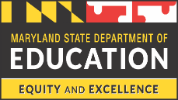
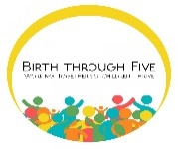
Local Early Childhood Advisory Councils Improvement Grant FY2021

Through the Preschool Development Birth through Five Renewal Grant, the local councils will have the opportunity to apply for quality improvement grant for up to $25,000 per year ($75,000 over three years). The purpose of this grant is:
- To support the capacity of Local Early Childhood Advisory Councils (LECACs) to serve as local governance entities by leveraging resources, coordination, and collaboration to support local early childhood system development that aligns with statewide goals and priorities.

- To support LECACs to demonstrate a focus on one or more of the following prioritized Statewide System Development Goals:

- Strengthen availability and access by increasing availability and choice for all families and especially vulnerable families, decreasing barriers, serving more children with special needs in inclusive settings, and improving coordination between Early Care and Education (ECE) and health services.

- Improve and support program quality by increasing quality across sectors, focusing on equity, increasing kindergarten readiness for all children, and improving capacity to meet infants’ and children’s mental health needs

- Deepen family engagement by increasing families’ awareness of high-quality programs, expanding two-generational programming, and enhancing families’ opportunities to engage.

- Ensure successful transition experiences by strengthening institutional support for transitions, supporting families through transitions, and improving transition-focused professional development opportunities.

- Expand and enhance workforce development by improving professional development opportunities, strengthening equity, coordination and alignment efforts, and improving compensation for ECE professionals.

- Improve systems for infrastructure, data and resource management by improving coordination across agencies, modernizing the data system, using resources in ways that promote equity, and streamlining funding mechanisms.

Project Period: July 1, 2020 –December 31, 2022
Technical Assistance Webinar: Wednesday, April 1, 2020 2:00 p.m. – 3:00 p.m

